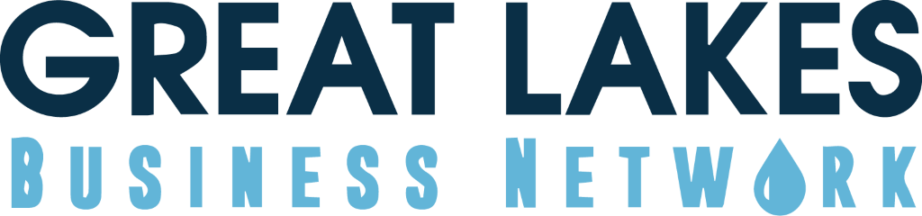
FOR IMMEDIATE RELEASE: Tuesday, May 11, 2021
Contact: Stephanie Cepak, Byrum & Fisk Advocacy Communications, scepak@byrumfisk.com
Enbridge facing millions in fines
Gov. Gretchen Whitmer calls for 'disgorgement of profits’ in latest Line 5 development
LANSING, Mich. – Members of the Great Lakes Business Network (GLBN) issued the following statements after Gov. Gretchen Whitmer called for the disgorgement of profits on Line 5 after Enbridge, once again, refuses to comply with legal contracts that require the shutdown of the pipeline.
Great Lakes Business Network member Ian Bund has estimated the current net cash flow is benefiting Enbridge in the order of $2 million a day.

Bund’s financial expertise comes from spending the last 50 years in active venture capital investments, including 43 years helping to build the venture capital industry in Michigan. Line 5, which transports over 23 million gallons of oil and natural gas liquids a day from Alberta Canada to Ontario, has been ordered to be shut down by Wednesday.
“We have a foreign corporation that has mislead the public and their investors on the risk that Line 5 poses to the Great Lakes and the Michigan economy,” said Ian Bund, owner of Angell Farm LLC and member of the Great Lakes Business Network. “Instead of taking the past six months to prepare for this transition, they have spent millions in advertising in Michigan trying to sell a different narrative. This is a pattern of behavior that can’t be overlooked.”
Enbridge’s rupture of Line 6B in the Kalamazoo River spilled more than 1 million gallons of oil. During the Kalamazoo River oil spill clean-up, another GLBN member, Larry Bell, had to sue Enbridge for impacts to his business when Enbridge was illegally attempting to build an oil remediation pad right next to the brewery, which could have carried chemicals from the cleanup into his operations.
“We are blessed with the most amazing bodies of water in the world – the Great Lakes – which provide safe drinking water for millions and are the backbone to our economy,” said Larry Bell, owner of Bell’s Brewery and GLBN co-chair. “A spill from Line 5 would destroy all of that, which Governor Whitmer understands and thankfully has stood up against. I’ve witnessed the lawless actions by this foreign corporation and support the efforts by Governor Whitmer and Attorney General Nessel to hold this company accountable.”
The Great Lakes Business Network supports the shutdown of Line 5 after years of easement violations that show a pipeline that has never been properly supported, the protective coating is failing at alarming rates, the pipeline has bends that exceed the terms of the easement and the pipelines are constantly being damaged by external forces.
###

